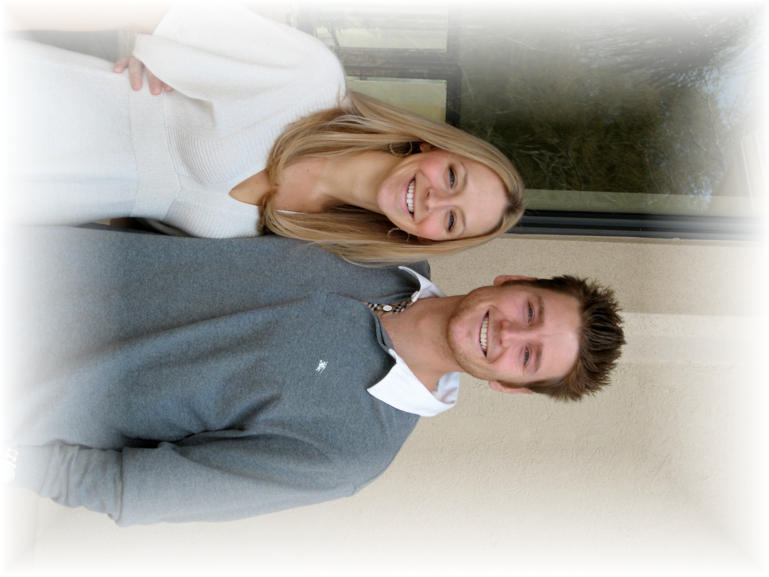
Come Join the Celebration
With Stephanie and Philip

You are invited to join us at our
Destination Wedding Celebration
In Jamaica
January 06, 2009 – January 11, 2009

Wedding is January 09, 2009
at 4:00 pm at the Chapel on the Beach

Travel and Accommodation from Houston

Deluxe: $1395.00
Premium: $1420.00
Oceanfront: $1402.00
(Air, Transfers, taxes, gratuities and All-Inclusive Resort)
*Prices are per person and double occupancy. 3rd person rates are available upon request.
Please call or email requests for Airfare from other destinations or suite options

Delta Airlines
Carr/Flt# Date Departure Arrival
DL / 668 06JAN2009 IAH 550A ATL 854A
DL / 359 06JAN2009 ATL 945A MBJ 1238P

DL / 360 11JAN2009 MBJ 138P ATL 434P
DL / 57 11JAN2009 ATL 650P IAH 805P

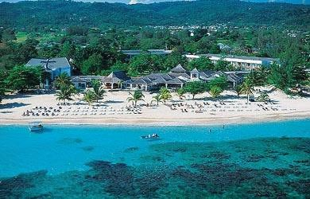
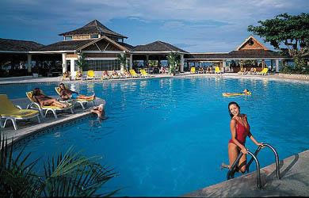

Breezes Runaway Bay – All Inclusive
(meals, drinks, entertainment, activities and green fees)

- The perfect off-ramp for people on the fast track. Twenty lush, green acres tucked away on the finest expanse of beach on Jamaica’s famed North Coast make Breezes Runaway Bay one of the world’s truly great escapes.

- View Rooms and Resort click here

Spring Chicken Travel Sandra Rogers 281-960-5678
sandra@springchicken.com
www.springchicken.com

